Greg Spiller
Machine Tool Millwright / CNC Field Service Technician

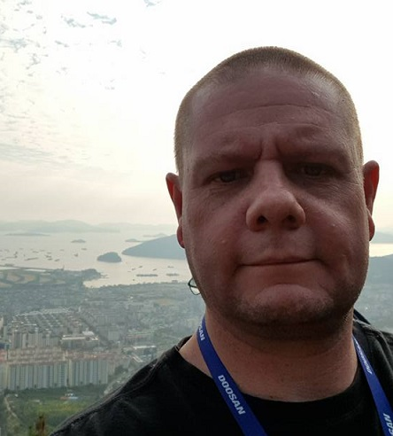

Contact Details
Telephone number: +27 66 208 2278
Home address: 5 Avocet Road, Kempton Park, Gauteng, South Africa.
Email address: gregspiller@axxess.co.za

Summary of Career

- I have been working as a millwright / field service technician for 13 years.

Education

- Grade 12 completed in 1997
- National Certificate N2 completed in 1996
- National Certificate N3 completed in 1997
- Apprenticeship type: Machine Tool (CNC) Millwright
- Apprenticeship time: January 2012 to October 2015
- Trade Test date: February 2016

Technical Training:

- Millwright apprenticeship (1 Year Theory, 2 Years practical) – 3 Years
- Advanced Maintenance Pneumatics – 3 Days
- Advanced Maintenance Hydraulics – 4 Days
- Advanced Overhead Crane Training (20 ton) – 3 Days
- Advanced Fanuc Training (In-Company) – 4 Weeks

General Training:

- Hirt & Carter Computer Training (Graphic Design) – 1997 - 1998
- Executive School for Computers (Computer Science) – 2000 - 2001

Work Experience
October 2012 – present, Retecon Service, www.retecon.co.za, Town of Kempton Park, South Africa.
Machine Tool Millwright / Field Service Technician

Reference: Konstantine Malinov, Senior Technician, Tel: +27 11 976 8600,
Cell: +27 83 326 6209, Email: konstantine@retecon.co.za

Mechanical Experience
- Hydraulic
  - Installation of new valves
  - Overhauling old valves
  - Trouble Shooting of valves
  - Installation of new Cylinders
  - Overhauling old cylinders with new seals
  - Trouble Shooting of cylinders is quite common, if it is bypassing or visibly leaking then most of the time the cylinder is at fault and either a rebuild is necessary or a replacement is to be fitted depending on the customer.
- Spindle Overhauling
  - Overhauled spindle bearings on both Doosan Lathes as well as Doosan Milling Machines.
  - Re-pack bearings with spindle grease according to specification charts and rebuilt again.
- Bearings & Ball screw Overhauling
- Replacement with new parts to replace old parts that have been worn out over time.
- Stripping the old housings off and removing the ball screw.
- Measure the old bearings with an outside micrometre and measure the new bearing set the same way
- AC Servo Motors
- Troubleshooting and replacement of these specialized electrical drive-controlled motors.
- Hydraulic and Coolant Pumps (both lathes and Milling Machines)
- Replacing pumps
- Stripping pumps for assessment purposes
- Gearboxes (Larger Doosan machinery such as the DB 130 horizontal boring machine)
  - Stripping and replacing gears, spline shafts and bearings in gearboxes.
- CNC Lathe & Milling Machine Rebuilds (Older machines with box slides and turcite)
  - Stripping, Assessing, Cleaning, Ordering new parts and assembling older lathes and Milling machines for the purpose of rebuilding them.
  - Scrapping and cleaning off of old Turcite.
  - Gluing and measuring with engineering blue and scaping of new turcite onto box slides and gibs.
- CNC Machine Tool Installations & Commissioning
  - Installation and commissioning of new CNC lathe and milling machines.
  - Overseeing the riggers offloading and unboxing the new machine tool at a customer.
  - Helping riggers to place the machine where the customer would like it to stand.
  - Removing transportation brackets and packaging from the new machine.
  - Wiring 3 phase power to the main switch of the machine and tapping the transformer.
  - Levelling the machine to factory specification.
  - Wiring plugs up to the machine interface
  - Filling up the coolant tank
  - Filling up all the lubricants (oils) according to factory specifications.
  - Switching on the new machine and testing pumps and features on the new machine
  - Training the customer on the working and maintenance of the new machine.
  - Finally Signing all the paperwork and commissioning certificates with the customer.
- Pneumatics
  - Installation of new directional control valves
  - Overhauling of old valves
  - Trouble Shooting of valves
  - The older valves rarely give trouble but if they do it is mostly due to bad maintenance or not filling up the required lubricating oil
  - The new valves are very reliable and do not require a lubricator due to the construction of the new types of seal material.
  - Pneumatic Cylinders – replacing
    - Overhauling – seal replacement

Electrical Experience
- Variable Speed Drives and Motors
  - Troubleshooting
  - Replacing Drives or Motors or both together
  - Removing Drives and Motors for testing purposes
- Contactors
  - Troubleshooting
  - Replacement of Faulty or burnt out Contactors
- Relays
  - Troubleshooting
  - Replacement of Faulty or burnt out Relays
- Transformers
  - Working on electric motors and pumps such as Doosan Machine Tools which is 3 phase 220 Volt Specification.
  - Re-tapped incoming voltage from 3 phase 400 Volt into the main isolator to out of the Isolator down to 3 phase 220 Volt
- Bridge Rectifiers
  - Lighting for Doosan Machine Tools
- PLC
  - Use the ladder function to fault trace alarm functions in Fanuc on Doosan Machine tools.
  - using the status function to check if input signals are received in order to execute the output.
  - Using the keep relays function to switch off a machine component during fault tracing.

Other duties:
- Read blueprints of machine layouts, diagrams and schematic drawings for fault tracing and installations.
- Install, align, dismantle and move stationary industrial machinery and mechanical equipment, such as pumps, fans, tanks, and conveyors according to layout plans using hand and power tools.
- Operate hoisting and lifting devices such as cranes, jacks and forklifts to position machinery and parts during the installation, set-up and repair of machinery.
- Inspect and examine machinery and equipment to detect and investigate irregularities and malfunctions.
- Adjust machinery and repair or replace defective.
- Operate machine tools such as lathes and grinders to fabricate parts required during overhaul, maintenance or set-up of machinery (for new ballscrew and bearing jobs when spacer grinding is needed).
- Assist customers with applications, new machine training and problem resolution.
- Direct communication with customers about the state of their machinery, whether it be a repair or a service.
- Complete jobs Cards and keep commitments to management and customers.
- Daily admin duties such as timesheets, quotations and ordering of spare parts for customer machines that need repair, Job planning for new jobs and service calls, and ensuring that Parts arrive on time for machine repairs to be carried out.
- Attend monthly staff meetings.

July 2009 – December 2011, Amrod Corporate Gifts & Clothing,
https://legacy-web.amrod.co.za/ , Town of Sandton, South Africa.
DTP Layout Artist

Reference: Nimrod / Amit, Directors of Amrod, Tel: +27 11 457 9900,

- Pad & Screen printing of all corporate gifts & clothing
- Including but not limited to; pens & pencil sets, coffee mugs, t-shirts, flasks, stress balls etc.
- Applications that I used at Amrod on PC:
  - CorelDraw
  - Adobe Photoshop
  - Amtrack, Layout Assistant

November 2006 – July 2009, Stallion Signs & Graphics, Town of Johannesburg, South Africa.
Senior Graphic Designer

- Redrawing of logos for signage and clear-cut vinyl
- Design of packaging for L’Oreal, Garnier, Lancome & Maybelline
- Applications that I used on PC:
  - CorelDraw
  - Adobe Photoshop

May 2006 – July 2006, Megabits CC, http://www.megabits.co.za, Town of Kempton Park South Africa.
Junior IT Technician

The company had 2 large private school networks to maintain and manage, I was involved in doing this as the schools were adjacent to each other down the same street.
- Building Computers from scratch, installing an operating system like windows and loading software onto them.
- Wire up networks from basic to complex and how to use a windows based server to manage the network.

September 2005 – January 2006, Nuffield Print & Graphics, Town of Springs, South Africa.
Senior Graphic Designer

- General Printing Work
- Design of business card, business forms, letterheads, decals and continuous print work
- Applications that I used on PC:
  - CorelDraw
  - Adobe Photoshop
  - Adobe Pagemaker
  - Adobe Illustrator

May 2005 – September 2005, New Era Press Printing, Town of Springs South Africa.
Graphic Designer & Negative/Positive printer

- General Printing Work
- Design of business card, business forms, letterheads, decals and continuous print work
- Applications that I used on PC:
  - CorelDraw
  - Adobe Photoshop
  - Adobe Pagemaker
  - Adobe Illustrator

November 2003 – May 2005, Caxton East Rand, http://www.caxton.co.za, Town of Boksburg South Africa.
Digital Scanner / Photo Retoucher

- Scanning and retouching of images for the newspapers of the east rand
- Adding Effect and Filters to images
- Applications that I used on PC:
  - CorelDraw
  - Adobe Photoshop
  - Adobe Pagemaker

January 2002 – November 2003 Caxton Kempton Express, http://www. https://www.citizen.co.za/kempton-express, Town of Kempton Park South Africa.
Advert Setter & Designer

- Designing of adverts for the newspaper
- Layout of the finalised adverts in the required spaces of the newspaper
- Applications that I used on PC:
  - CorelDraw
  - Adobe Pagemaker

April 1998 – June 1998, Deer Graphics, Town of Midrand South Africa.
Junior Graphic designer

- Design, Printing and Cutting of business cards
- Design of business forms & letterheads
- Applications that I used on PC:
  - CorelDraw
  - Adobe Photoshop

My family
This is my wife Vanessa (46).
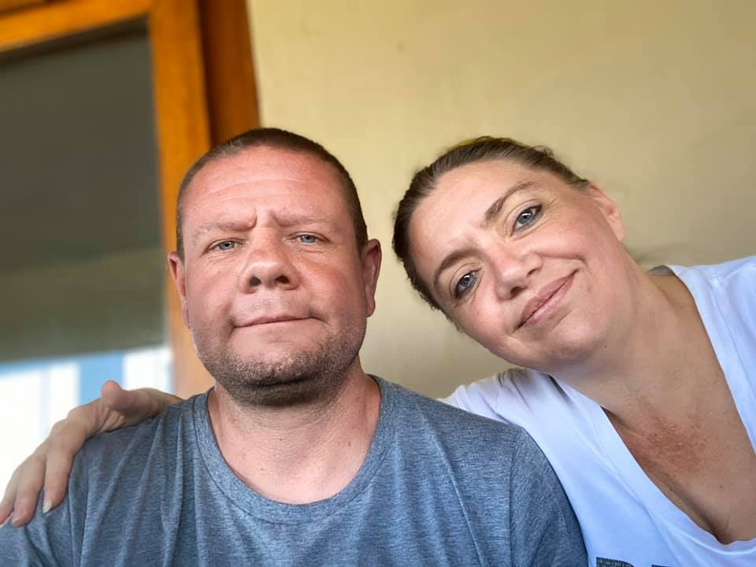

This is my fur baby family
This is my fur baby family with Vanessa,
From left to right is: Toby, Scoobie, Bruno & Simba.

